|  |  |  |
| --- | --- | --- |
| SCHOOL OF INFORMATION AND TECHNOLOGY | | |
| NAME: Caccam, Jesus Allyson O. | DATE PERFORMED: September 26, 2024 | /50 |
| Section: IDC2 | DATE SUBMITTED: |

# SYSADM1 – Monitoring Print Services in Windows Server 2019

# Requirement:

* A virtual machine running Linux and Windows OS

Part 1: Setting Up Print Services

1. Install and configure **print.srv** domain
2. Connect one client to the recently created domain

|  |  |
| --- | --- |
| Server | Client |
|  |  |
|  |  |

1. Install Print Services Role:

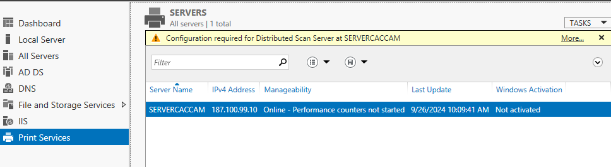

1. Search the internet for any printer installer and convert it to iso  
   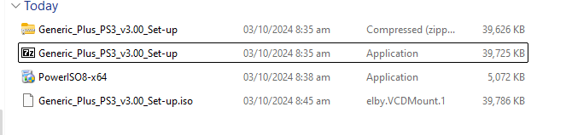
2. Install and deploy it as network printer

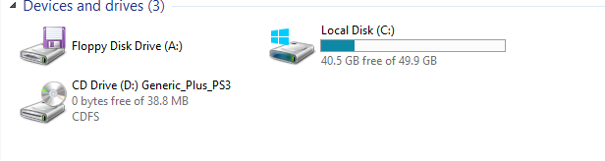

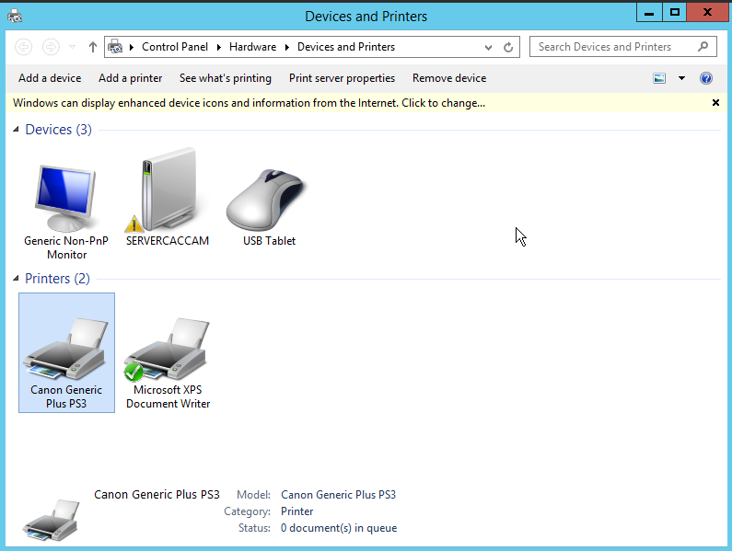

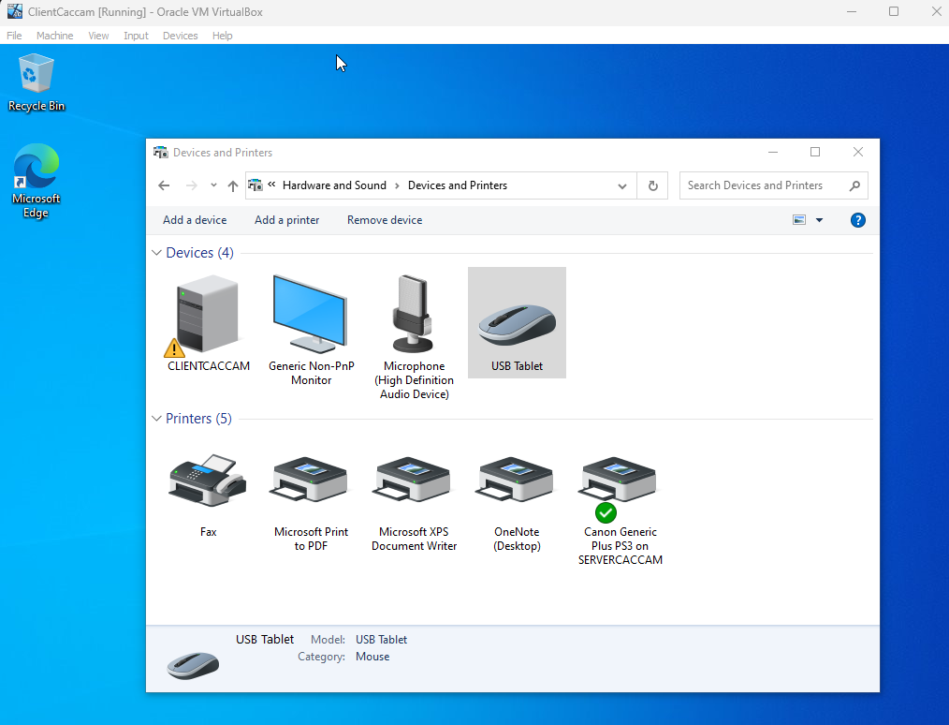

Part 2: Monitoring Print Services

Objective: Familiarize yourself with monitoring tools available in Windows Server 2019.

1. Event Viewer:
   * Open Event Viewer (run eventvwr.msc).
   * Navigate to Applications and Services Logs > Microsoft > Windows > PrintService.
   * Review logs for print jobs, errors, and warnings.  
       
     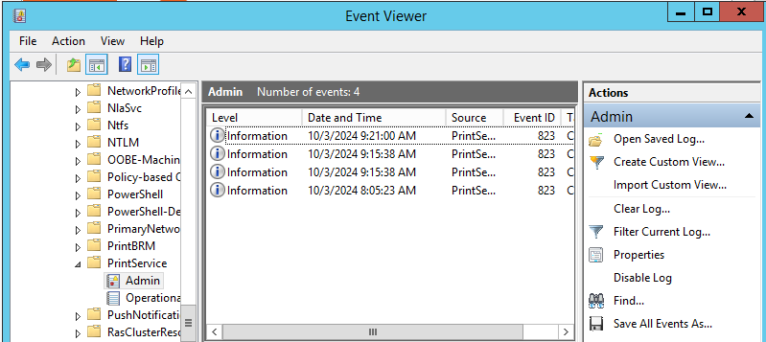
2. Performance Monitor:
   * Open Performance Monitor (run perfmon).
   * In the left pane, expand Data Collector Sets > System.
   * Right-click System Performance and select Start.
   * Monitor performance metrics related to print services.  
       
     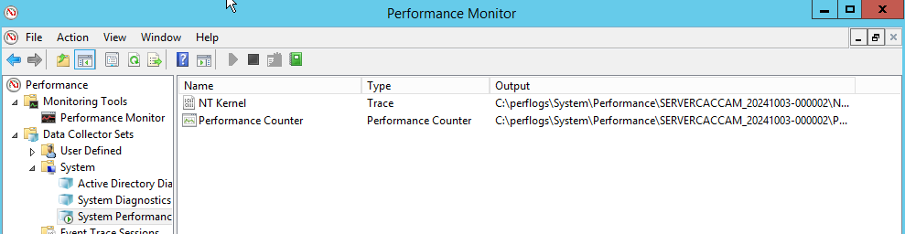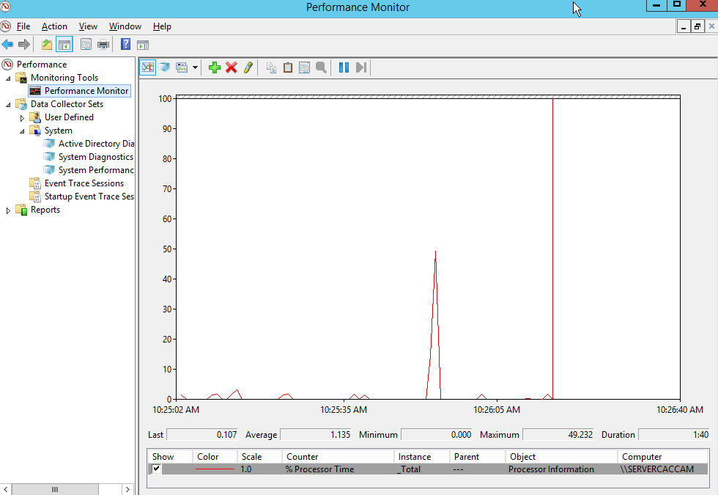
3. Using Print Management Console:
   * Open Print Management from Server Manager.
   * View active print jobs and their status.
   * Use the Printers node to check the status of all printers.  
       
     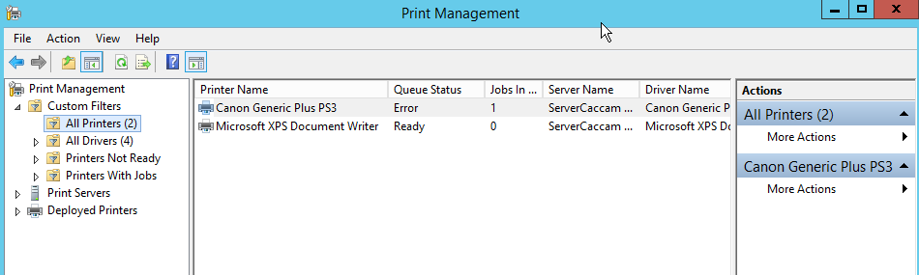

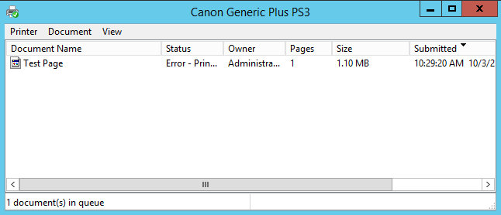

Part 3: Exploring Third-Party Monitoring Tools

1. Research at least two third-party print monitoring tools
   * Consider factors such as features, pricing, and compatibility with Windows Server 2019.  
       
     - **MangeEngine OpManager**  
      The features of this third party tool is, it has a comprehensive monitoring, tools,and print queue monitoring. And when it comes to its price it is base on the numbers of devices that are being monitored. And It is compatible for server 2019 and above.  
       
       
     -**PaperCut Print Logger**  
     The features of this third party tool is it has a real time activity logging, export options, automatic printer detection, and multi language support. And for it’s pricing, it is free. However the usage will be limited and may not receive daily updates
2. Install and Configure:
   * Choose one of the tools to install in your environment.
   * Follow the installation instructions provided by the tool's documentation.
   * Configure it to monitor your print services.
3. Test and Report Findings:
   * Generate a report or dashboard from the tool.
   * Analyze the collected data (e.g., print volume, errors, user activity).

Rubric

| **Criteria** | **1 (Unsatisfactory)** | **2 (Needs Improvement)** | **3 (Satisfactory)** | **4 (Good)** | **5 (Excellent)** | **Score** |
| --- | --- | --- | --- | --- | --- | --- |

|  |  |  |  |  |  |  |
| --- | --- | --- | --- | --- | --- | --- |
| **Part 1: Setting Up Print Services** |  |  |  |  |  |  |

|  |  |  |  |  |  |  |
| --- | --- | --- | --- | --- | --- | --- |
| **Domain Installation** | No domain created | Domain created with errors | Domain created correctly | Domain configured well | Domain configured and documented thoroughly |  |

|  |  |  |  |  |  |  |
| --- | --- | --- | --- | --- | --- | --- |
| **Client Connection** | Client not connected | Connection attempt failed | Client connected but with issues | Client connected correctly | Client connected and documented well |  |

|  |  |  |  |  |  |  |
| --- | --- | --- | --- | --- | --- | --- |
| **Print Services Role Installation** | Role not installed | Role installed with issues | Role installed correctly | Role installed and configured | Role installed, configured, and documented thoroughly |  |

|  |  |  |  |  |  |  |
| --- | --- | --- | --- | --- | --- | --- |
| **Printer Installer Conversion** | No installer found | Installer conversion attempted but failed | Installer converted but not used | Installer converted and used | Installer converted, used, and documented well |  |

|  |  |  |  |  |  |  |
| --- | --- | --- | --- | --- | --- | --- |
| **Network Printer Deployment** | Printer not deployed | Deployment failed | Printer deployed but not functional | Printer deployed correctly | Printer deployed, tested, and documented well |  |

|  |  |  |  |  |  |  |
| --- | --- | --- | --- | --- | --- | --- |
| **Part 2: Monitoring Print Services** |  |  |  |  |  |  |

|  |  |  |  |  |  |  |
| --- | --- | --- | --- | --- | --- | --- |
| **Event Viewer Usage** | Event Viewer not opened | Opened but no logs reviewed | Logs reviewed but superficial | Logs reviewed with some analysis | Logs reviewed with thorough analysis and documentation |  |

|  |  |  |  |  |  |  |
| --- | --- | --- | --- | --- | --- | --- |
| **Performance Monitor Usage** | Performance Monitor not opened | Opened but no metrics monitored | Metrics monitored but not analyzed | Metrics monitored with some analysis | Metrics monitored, analyzed, and documented thoroughly |  |

|  |  |  |  |  |  |  |
| --- | --- | --- | --- | --- | --- | --- |
| **Print Management Console Usage** | Console not opened | Opened but functionality not used | Active jobs viewed superficially | Active jobs viewed with some detail | Active jobs viewed and documented thoroughly |  |

|  |  |  |  |  |  |  |
| --- | --- | --- | --- | --- | --- | --- |
| **Part 3: Exploring Third-Party Tools** |  |  |  |  |  |  |

|  |  |  |  |  |  |  |
| --- | --- | --- | --- | --- | --- | --- |
| **Research on Tools** | No tools researched | Research incomplete | Research on one tool completed | Research on two tools with some analysis | Research on two tools, detailed analysis, and comparison |  |

|  |  |  |  |  |  |  |
| --- | --- | --- | --- | --- | --- | --- |
| **Installation and Configuration** | Tool not installed | Installation failed | Tool installed but not configured | Tool installed and configured with issues | Tool installed, configured, and documented thoroughly |  |

|  |  |  |  |  |  |  |
| --- | --- | --- | --- | --- | --- | --- |
| **Reporting Findings** | No report generated | Report lacks detail | Report generated but lacks analysis | Report generated with some analysis | Comprehensive report with thorough analysis and documentation |  |